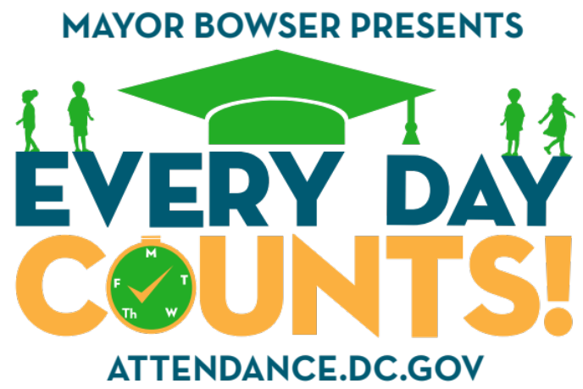

LEA MARKETING TOOLKIT

ATTENDANCE SUMMIT
LEA TOOLKIT FOR ATTENDANCE SUMMIT

Welcome to the Attendance Summit online toolkit for local education agencies (LEAs). The objectives of this toolkit are to:
- Provide you with the communications tools to spread awareness and increase your community’s involvement at the upcoming summit
- Ensure you have the right information and graphics to use to promote your participation at the Attendance Summit

Summit Details:
- What: Attendance Summit
- Who: Parent associations, educators, local business owners, students, and community organizations
- When: Saturday, April 21st, 2018 – 9:30 am – 3:00 pm
- Where: Ron Brown High School, 4800 Meade Street Northeast, Washington, DC 20019
- Why (About): Participants will gain knowledge of research, local resources, and best practices that can help them improve student attendance in their neighborhoods. Throughout the day, participants will engage with governmental leadership, deepen connections through working sessions, and learn direct insights from students and families. School leadership, staff, and families are encouraged to attend as a group, as they will have an opportunity to reflect together on next steps.
- RSVP Link: attendance.dc.gov/summit

What You’ll Find In This Toolkit
This online toolkit will provide you content that you can use to provide information to your families and community about the Attendance Summit. Below you’ll find:
- Basic information about the Attendance Summit
- Content for your newsletter
- Posts for Facebook, Instagram, and Twitter

Attached to our original email, you can access graphics and information to share, such as:
- A printable Attendance Summit poster, including a modifiable poster for your school
- A graphic to share via your newsletter or social media posts

Spread the Word
As a participating LEA, we ask that you encourage and inform the communities you serve to:
- Attend the Attendance Summit
- Ask students, parents, and community members to sign the Every Day Counts! pledge and commit to attending school 100% of the time, especially before and after Spring Break – which is often a period of decreased school attendance

Newsletter Content
Whether you send a snail mail, an electronic newsletter, or would like to share messaging through a school loudspeaker, below you’ll find content that you can use to provide information to your community about the Attendance Summit.

Save the date and join the Attendance Summit | Saturday, April 21, 2018 from 9:30AM – 3PM | Ron Brown High School – 4800 Meade Street NE | For more info go to: attendance.dc.gov/summit | Twitter: @DMEforDC | #EveryDayCounts

The Deputy Mayor for Education’s team is excited to bring you the Attendance Summit, bringing DC parents associations, educators, local business owners, students and community organizations together to discuss local resources and promising practices for improving student attendance in your neighborhood!

Additionally, commit to your neighbors and community by signing the Every Day Counts! attendance pledge at attendance.dc.gov/CountMeIn!

Social Media Content
Below you’ll find ready-to-post content for your organization’s Facebook or Twitter accounts. Please find the photos and graphics attached to this email. When writing customized content, please include @DMEforDC on Twitter so we can share or retweet.

Attendance Summit:
- Join us on 4/21 for @DMEforDC’s Attendance Summit, where we’ll be coming together to discuss ways and resources to help DC students improve their school attendance. Register for free at: attendance.dc.gov/summit #EveryDayCounts
- Mark your calendars! The Attendance Summit is just around the corner on 4/21. Join your DC community to discuss our students’ attendance, tools, and resources to help them thrive. Register today at: attendance.dc.gov/summit #EveryDayCounts
- We all have the chance to help our students increase their school attendance. Join us in discussing how we can help at @DMEforDC’s Attendance Summit on 4/21. Register today at: attendance.dc.gov/summit #EveryDayCounts

Every Day Counts! Pledge:
- Students, families, & community members: Sign the #EveryDayCounts pledge and commit to increase school attendance in DC and enter to win prizes such as tickets to sporting events of even a new laptop! Learn more at attendance.dc.gov/CountMeIn
- [Name of school] students - your future awaits! Step 1: Show up! Commit to improving your school attendance. Step 2: Sign the #EveryDayCounts pledge at attendance.dc.gov/CountMeIn. Step 3: Earn rewards from our partners including game tickets, a bike, or customized sneakers! #EveryDayCounts
- (To be posted ahead of spring break) Enjoy your #SpringBreak! Get some rest and catch up with your friends, because when school’s back in session, it’s time to show up! Sign the #EveryDayCounts pledge: attendance.dc.gov/CountMeIn

