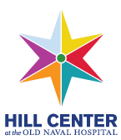
SAMPLING OF
UPCOMING EVENTS
A VIBRANT HOME FOR ARTS, CULTURE AND CITY LIFE ON CAPITOL HILL

September 14-January 6
Fall Solo Exhibitions

Sunday, October 2
EAST Workshop: Visual Poetry with Briget Heidmous

American Roots Concert: The Revelers

Monday, October 3
Advanced Drawing Techniques: Watercolor Classes Begin

Tuesday, October 4
Kitchen 101: Knife Skills

Saturday, October 8
Adobe Lightroom Demo

A Trip to Thailand w/ Globetrotter Marianne Tshihamba

Sunday, October 9
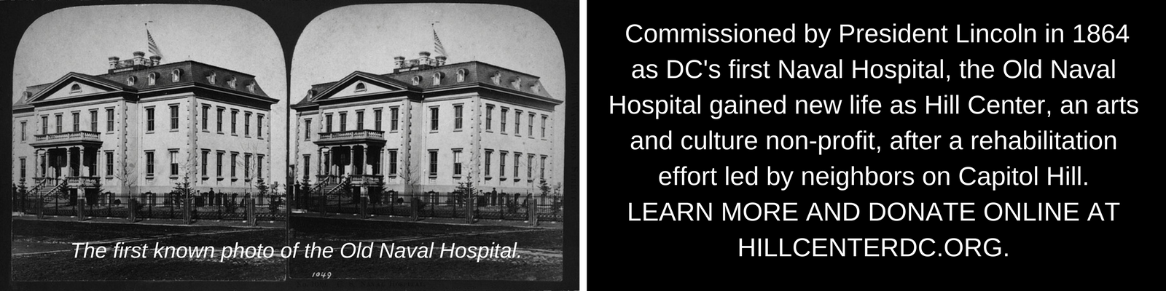
Cathy Fink & Marcy Marxer in Concert
Tuesday, October 11
Virtual Introduction to Adobe Lightroom Classic Classes Begin

Wednesday, October 12
Pulitzer Prize-Winning Historian Marcia Chatelain in Conversation w/ Noted Chef Carla Hall

Thursday, October 13
Easy Vegetarian Indian Cooking: Time for Tiffin – Indian Snacks made Easy

Friday, October 14
Family Happy Hour
with King Bullfrog

Saturday, October 15
Studio Arts Workshops w/ Christine Vineyard
-Contemporary
Watercolors
-Introduction to
Linocut Printmaking
-Sip ‘n Paint

Sunday, October 16
Frontlines: Infant and Child CPR

Tuesday, October 18
Profs & Pints DC: Medieval Monsters

Wednesday, October 19
Talk of the Hill w/ Bill Press: CBS Chief Washington Correspondent Major Garrett & Elections Expert David Becker

Saturday, October 22
Halloween Sugar Cookie Decorating

Storytelling: A Workshop in Creative Nonfiction

Sunday, October 23
Master Chef: Vegan Sweet & Savory with Sticky Fingers Owner Doron Petersan

Sunday, October 30
Global Sounds on the Hill: Celtic Fiddle-Guitar Duo Rakish

Ongoing Classes Include:
- Karate Classes with Warrior Fusion
- Wu Style Academy: Tai Chi Chuan
- Breathing Space Yoga
- Alcoholics Anonymous
- Kadampa Meditation Center
- Tippi Toes
- Super Soccer Stars
- Busy Bees
- Opera Starts with an Oh! with Opera Lafayette
- Mister Mike’s Music Together
- Studio One Dance
- Soaring Starts
- Adult French Classes
- Armed Services Arts Partnership (ASAP)
- Shakespeare Theatre Company
- Adult Drawing Classes
- Adobe Lightroom Classic for Digital Photography
- Piano Lessons w/ Gordon Tenney

Register for programs & events at:
Hillcenterdc.org/events/

Some programs are not listed because they are sold out. Please visit the above site to see all programming and/or join a waitlist.

Programmatic support provided by the Capitol Hill Community Foundation and the DC Commission on the Arts & Humanities.

